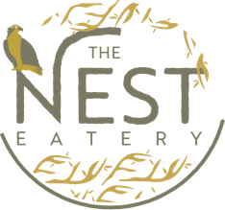

Event:
Robin Newman Birthday

Date:
December 10th, 2022

Station 1:
Hummus with carrots, cucumbers & cherry tomatoes
Pita bread
Assortment - Feta cheese, Kalamata olives, diced tomatoes, diced onions, pepperoncini
Tzatziki sauce
Greek Salad

Station 2:
Greek pasta with cherry tomatoes, Feta cheese, artichoke hearts, black olives
and sun-dried tomatoes
Goat cheese crostini - Crostini with Goat Cheese, Sun-Dried Tomatoes & Kalamata Olives
Spiced Moroccan Meatballs
Caprese skewers

Station 3:
Beef kabob
Chicken Souvlaki skewers
Greek chicken flatbread - Hummus, marinaded chicken, black olives, feta, tzatziki
Greek flatbread - Pesto, tomato, red onion, black olives, artichoke hearts, feta, arugula

Station 4:
Birthday cake
Honey & baklava

